

AP® Physics C
1983 Free Response Questions

The materials included in these files are intended for use by AP teachers for course and exam preparation in the classroom; permission for any other use must be sought from the Advanced Placement Program®. Teachers may reproduce them, in whole or in part, in limited quantities, for face-to-face teaching purposes but may not mass distribute the materials, electronically or otherwise. These materials and any copies made of them may not be resold, and the copyright notices must be retained as they appear here. This permission does not apply to any third-party copyrights contained herein.

These materials were produced by Educational Testing Service® (ETS®), which develops and administers the examinations of the Advanced Placement
Program for the College Board. The College Board and Educational Testing Service (ETS) are dedicated to the principle of equal opportunity, and their
programs, services, and employment policies are guided by that principle.

The College Board is a national nonprofit membership association dedicated to preparing, inspiring, and connecting students to college and opportunity.
Founded in 1900, the association is composed of more than 4,200 schools, colleges, universities, and other educational organizations. Each year, the
College Board serves over three million students and their parents, 22,000 high schools, and 3,500 colleges, through major programs and services in
college admission, guidance, assessment, financial aid, enrollment, and teaching and learning. Among its best-known programs are the SAT®, the
PSAT/NMSQT®, and the Advanced Placement Program® (AP®). The College Board is committed to the principles of equity and
excellence, and that commitment is embodied in all of its programs, services, activities, and concerns.

APIEL is a trademark owned by the College Entrance Examination Board. PSAT/NMSQT is a registered trademark jointly owned by the College Entrance Examination Board and the National Merit Scholarship Corporation. Educational Testing Service and ETS are registered trademarks of Educational Testing Service.
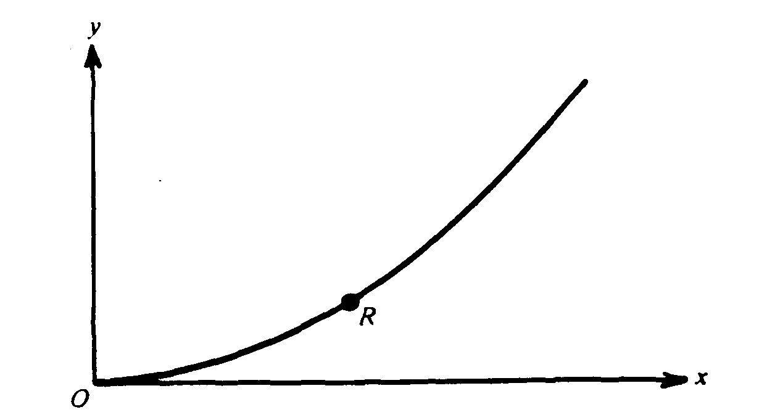
1983M1. A particle moves along the parabola with equation y = ½ x² shown above.
a. Suppose the particle moves so that the x-component of its velocity has the constant value v_{x} = C; that is, x = Ct
i. On the diagram above, indicate the directions of the particle's velocity vector v and acceleration vector a at point R, and label each vector.
ii. Determine the y-component of the particle's velocity as a function of x.
iii. Determine the y-component of the particle's acceleration.
b. Suppose, instead, that the particle moves along the same parabola with a velocity whose x-component is given by v_{x} = C/(1+x²)^{½}
i. Show that the particle's speed is constant in this case.
ii. On the diagram below, indicate the directions of the particle's velocity vector v and acceleration
vector a at point S, and label each vector. State the reasons for your choices.
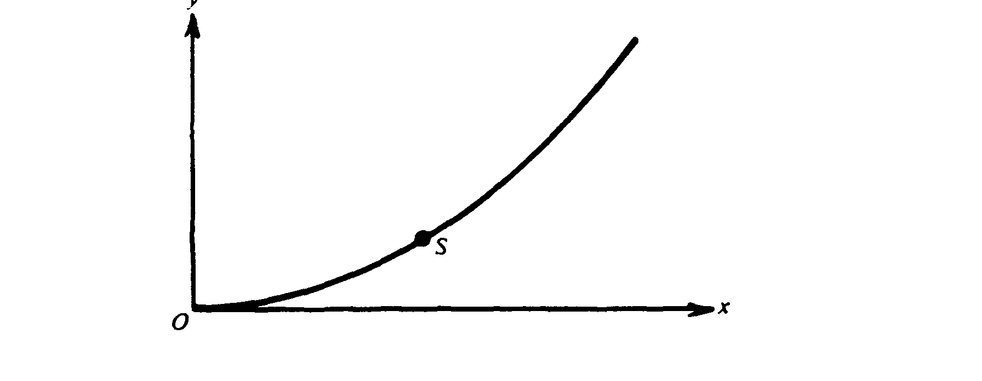
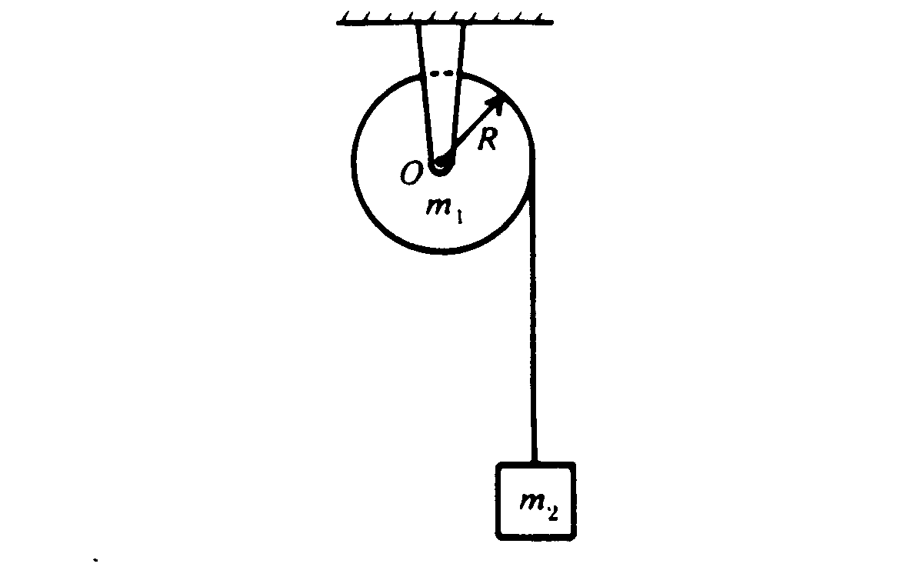
1983M2. A uniform solid cylinder of mass m₁ and radius R is mounted on frictionless bearings about a fixed axis through O. The moment of inertia of the cylinder about the axis is I = ½m₁R². A block of mass m₂, suspended by a cord wrapped around the cylinder as shown above, is released at time t = 0.
a. On the diagram below draw and identify all of the forces acting on the cylinder and on the block.
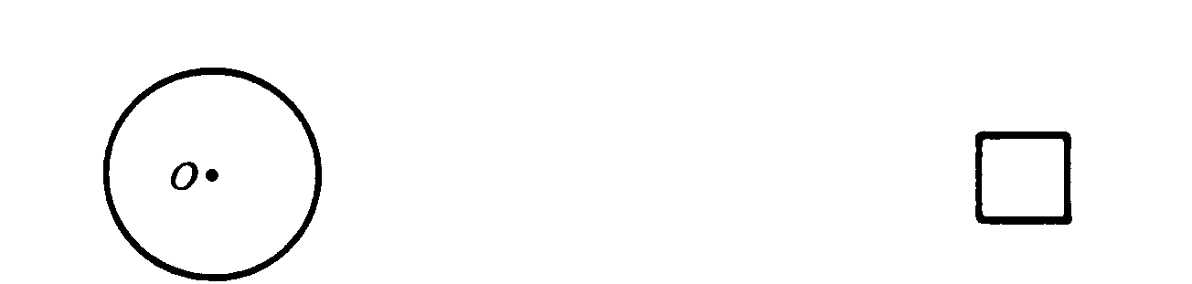
b. In terms of m_{l}, m₂, R. and g, determine each of the following.
i. The acceleration of the block
ii. The tension in the cord
iii. The angular momentum of the disk as a function of time t.

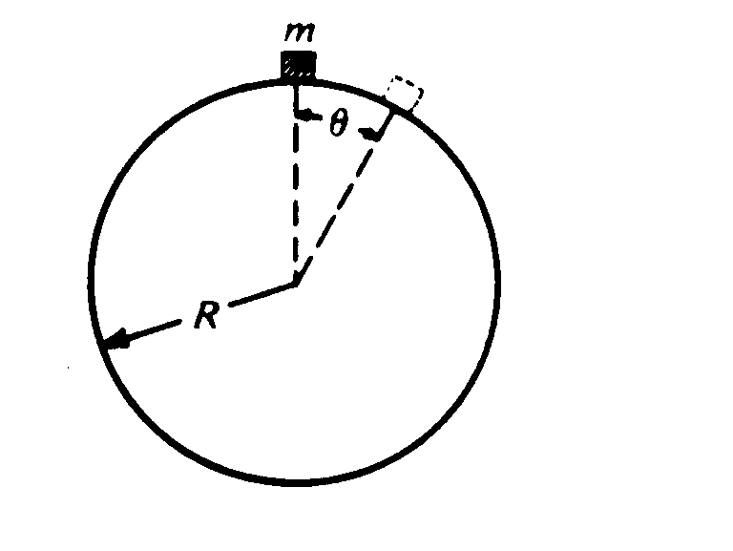
1983M3. A particle of mass m slides down a fixed, frictionless sphere of radius R. starting from rest at the top.
a. In terms of m, g, R. and θ, determine each of the following for the particle while it is sliding on the
sphere.
i. The kinetic energy of the particle
ii. The centripetal acceleration of the mass
iii. The tangential acceleration of the mass
b. Determine the value of θ at which the particle leaves the sphere.
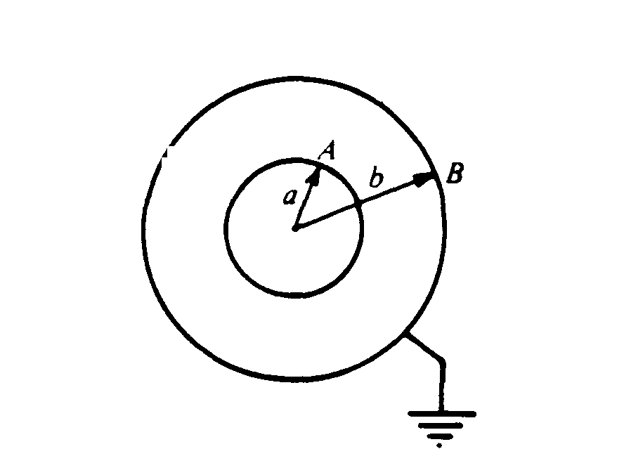
1983E1. Two concentric, conducting spherical shells, A and B, have radii a and b, respectively, (a < b). Shell B is grounded, whereas shell A is maintained at a positive potential V_{o}
a. Using Gauss's law, develop an expression for the magnitude E of the electric field at a distance r from the center of the shells in the region between the shells. Express your answer in terms of the charge Q on the inner shell.
b. By evaluating an appropriate integral, develop an expression for the potential V_{o} in terms of Q, a, and b.
c. Develop an expression for the capacitance of the system in terms of a and b

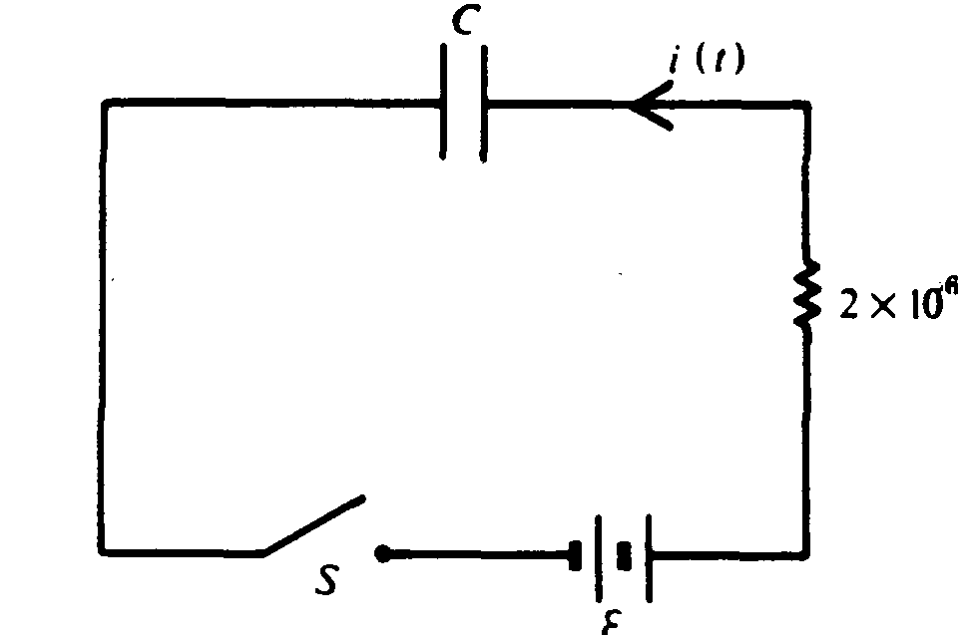
1983E2. The series circuit shown above contains a resistance R = 2 x 10⁶ ohms, a capacitor of unknown capacitance C, and a battery of unknown emf E and negligible internal resistance. Initially the capacitor is uncharged and the switch S is open. At time t = 0 the switch S is closed. For t > 0 the current in the circuit is described by the equation:
i(t) = i_{o}e^{-t/6} where i_{o} = 10 microamperes and t is in seconds.
a. Determine the emf of the battery.
b. By evaluating an appropriate integral, develop an expression for the charge on the right-hand plate of the capacitor as a function of time for t > 0.
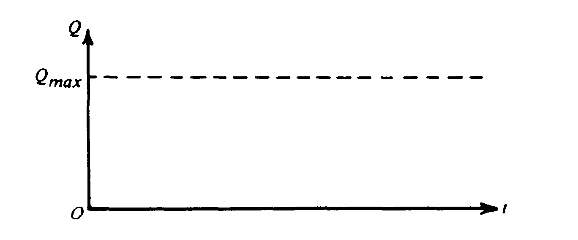
c. On the axes below sketch a graph of the charge Q on the capacitor as a function of time t.
d. Determine the capacitance C.

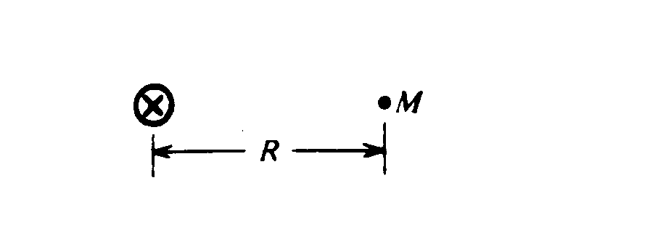
1983E3. a. A long straight wire carries current I into the plane of the page as shown above. Using Ampere's law, develop an expression for the magnetic field intensity at a point M that is a distance R from the center of the wire. On the diagram above indicate your path of integration and indicate the direction of the field at point M.
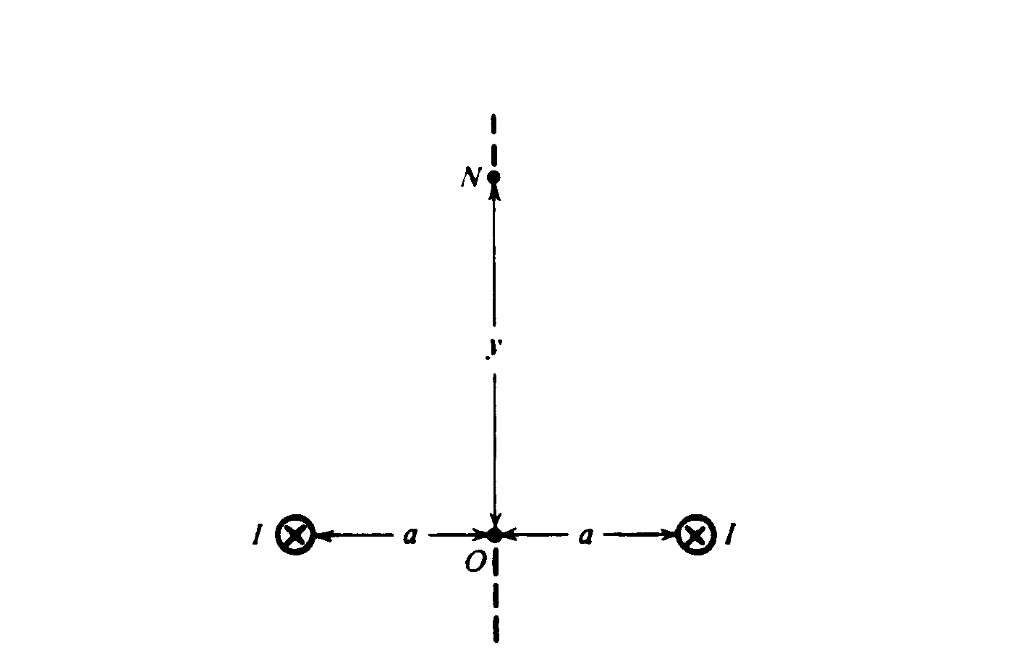
b. Two long parallel wires that are a distance 2a apart carry equal currents I into the plane of the page as shown above.
i. Determine the resultant magnetic field intensity at the point O midway between the wires.
ii. Develop an expression for the resultant magnetic field intensity at the point N. which is a vertical
distance of y above point O. On the diagram above indicate the direction of the resultant magnetic
field at point N.

